

Declaration Form

It is hereby declared that all the solutions provided by the team with Team ID:_ _ _IN- 69894744 _ _ _ _ _ _ _ _ _ _ _ _ _ _ _ in the Ideate: _ _ _ _ _ _ _ _ _ _ _ “Innovationeering”_ _ _ _ _ _ _ _ _ _ _ _ _ _ _ _ _ _ _ _ _ _ _ _ _ _ _ _ _will be given to Larsen & Toubro Electric and Automation (L&T E&A) and they can use it to improve their efficiency, bring in improvements or any other application which they want to use. The team members shall have no objection in giving their solution to L&T E&A and the Intellectual Property (IP) rights of the solution will belong to L&T E&A.

Techfest ID of Team Leader: _ _ _ _ _ __IN- 69894744 _ _ _ _ _ _ _ _ _ _ _ _ _

Name of Team Leader: _ _ _ _ _ _ _Abu M. Fuad _ _ _ _ _ _ _ _ _ _ _ _ _ _ _

Signature of Team Leader: _ _ _ _ 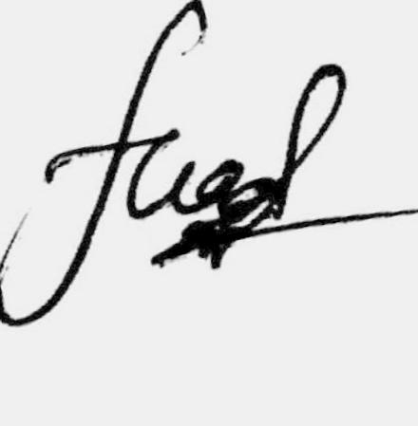_ _ _ _ _ _ _ _ _ _ _ _ _ _ _

Date: _ _ _ _ _ _ _25/11/2019 _ _ _ _ _ _ _ __ _ _ _
